Department of Computer Science and Engineering (Data Science)
CSDS-A | Batch A17 (CSE - Data Science, Section A)
CropSight: Smart Crop Delivery with AI-Based Price and Quality Intelligence
(CropSight)
S.No. | Student name | Roll / hall ticket no.
1 | G.PRANAVI | 23K91A6765
2 | G.SIRI CHANDANA | 23K91A6763
3 | A.NIKHIL | 23K91A6715
4 | G.VISHNU VARDHAN | 23K91A6754
Under the guidance of: K. Mounika, [DESIGNATION]
SCOPE AND LIMITATIONS
This document states what CropSight covers and what it deliberately does not, the assumptions behind the design, and the honest limitations of the system and of the evidence for it.

1 Scope of the Project

1.1 In scope
- Photographs of harvested produce (JPEG, PNG or WEBP, up to 8 MB) and eight crops: tomato, onion, potato, wheat, rice, mango, cotton and maize.
- Computer-vision feature extraction (eleven features) and a four-class grade with probabilities and a SHAP explanation of the top six features.
- A price model with a point estimate, a 15%-85% quantile band, a 30-day forecast, a best day to sell within a 14-day window and a grouped SHAP explanation.
- A transparent delivery-scoring engine that ranks buyers by price, distance, quality fit, reliability and spoilage risk and proposes a route.
- A role-gated marketplace (farmer, buyer, distributor, administrator) with a placed, confirmed, in-transit, delivered order lifecycle.
- A live sensor stream over WebSocket with threshold alerts, stored in a history table (the source is a simulator).
- A web application with sign-up and log-in, role dashboards, charts and an administrator page that discloses how each model was trained.
- An evaluation of both models, of the delivery scoring and of the simulator, a real-photograph transfer check, and an automated test suite.

1.2 Out of scope
- Pre-harvest tasks: soil analysis, irrigation, crop and fertiliser recommendation, which are the subject of the base paper [1].
- Training on a real labelled crop-image set or a real market-price feed; none was available, so both models are trained on synthetic data.
- Real sensor hardware, cold-chain devices and GPS tracking; the stream is simulated.
- Payments, invoicing, contracts and integration with government market portals.
- A language-model assistant or chatbot; the base paper includes a chatbot, this project does not.
- Grading of crops that are not in the list of eight, and of photographs with several lots or a cluttered background.
- Production hardening such as HTTPS termination, rate limiting, a hosted database and load testing.

1.3 Assumptions
- A photograph shows one lot of one crop, against a plain, bright background, in reasonable light.
- Quantities and asking prices are entered honestly by the user; they are not validated against market norms.
- Prices are in rupees per quintal (100 kg) and regions are the eight named regions of the demonstration data.
- The application runs on one machine with a single SQLite database for one demonstration deployment.

2 System Boundary
The two diagrams below show the boundary of CropSight: what flows across it (context diagram) and who may do what inside it (use-case diagram).
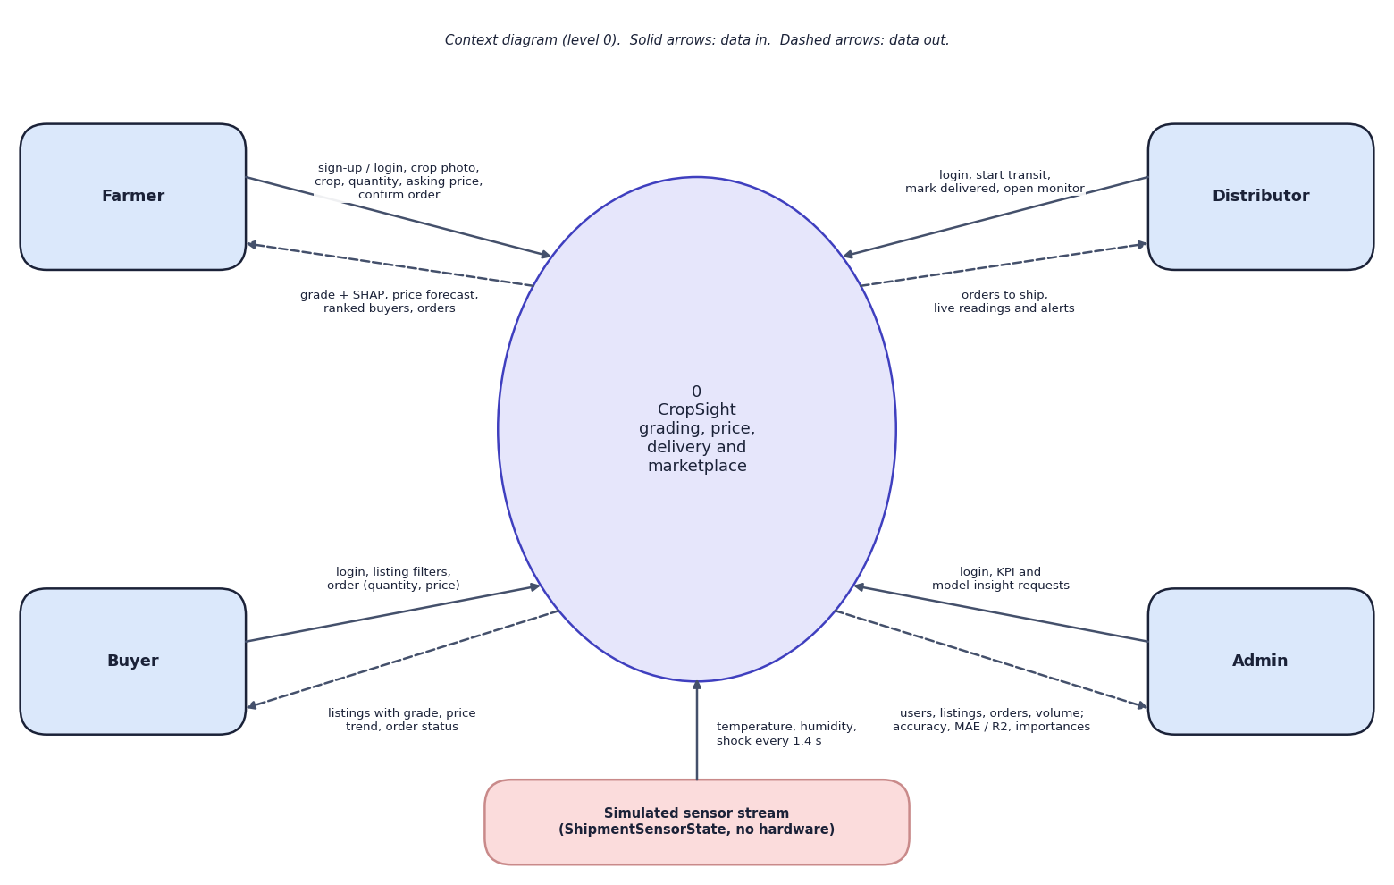
Fig. 1: Data-flow diagram, level 0 (context)
At the highest level CropSight is one process with five external entities. The farmer sends sign-up or login details, the crop photo, crop type, quantity, asking price and order confirmations, and receives the grade with its SHAP explanation, the price forecast, the ranked buyers and the orders. The buyer sends filters and orders and receives listings with grade, price trend and order status. The distributor sends login, start-transit and delivered actions and receives orders to ship and the live readings and alerts. The admin sends login and KPI or model-insight requests and receives user, listing and order totals, gross volume, and each model's accuracy or R2 and feature importances. The simulated sensor stream (ShipmentSensorState) supplies a temperature, humidity and shock reading every 1.4 seconds.
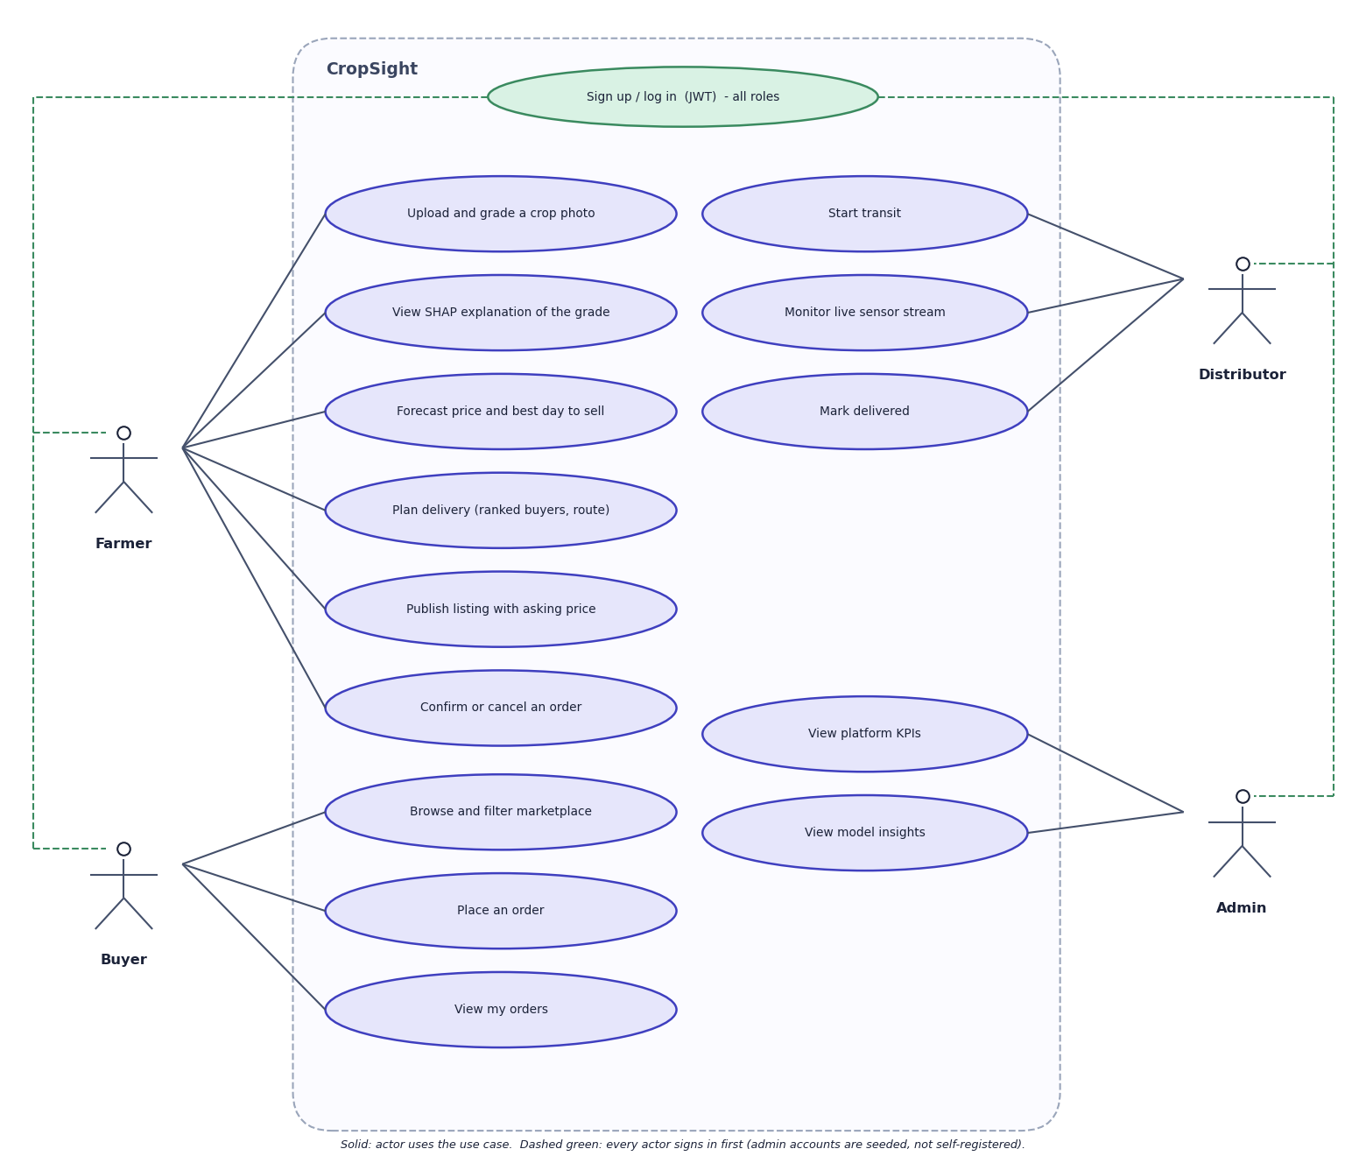
Fig. 2: Use-case diagram
Every actor first signs up or logs in. The farmer can upload and grade a crop photo, view the SHAP explanation of the grade, forecast the price and best day to sell, plan delivery, publish a listing with an asking price, and confirm or cancel an order. The buyer can browse and filter the marketplace, place an order and view their orders. The distributor can start transit, monitor the live sensor stream and mark an order delivered. The admin can view platform KPIs and the model insights. In the code the admin may also confirm, cancel or deliver any order; the diagram shows the use cases each role performs in normal operation. Admin accounts are seeded, not self-registered.

3 Limitations and Assumptions
- Synthetic training data. No real labelled crop-image set and no real market series were available. The grader is trained on feature vectors drawn from per-grade normal distributions, and the price model on a series produced by a formula with 3.5% noise. The high scores measure how well each model recovers its generator, not performance on farms or markets, and the administrator page says so.
- The grader does not transfer to real photographs. On 3,200 real fruit photographs it assigned grade B to about 99% of both fresh and rotten fruit; 99.8% of the real photographs lie outside the three-standard-deviation envelope of every synthetic grade profile.
- Classical machine learning, not deep learning. The grader is a random forest on eleven hand-crafted features. A convolutional network would need a real labelled image set that the project did not have.
- The price forecast is not a time-series forecast. The 30-day curve is the point model evaluated on 31 successive hash-generated market contexts; rainfall and temperature carry almost no importance (0.00009 and 0.00005), and the apparent gain from waiting to the best day (mean 14.6%) is an artefact of that context.
- Simulated sensors. The stream is a seeded random walk with injected events, without mean reversion: in 50 simulated shipments 91.6% of steps were in alarm, and a reconnection replays the same trajectory.
- Simulated buyer offers. The offered price of a buyer is the model price times a hash-derived factor between 0.90 and 1.18, so differences between buyers are not market information.
- Defects found by testing. The administrator volume figure multiplies a price per quintal by kilograms and overstates volume 100 times; a corrupt image with an image content type returns a server error and leaves a draft listing without a grade; crop, region, quantity and price are not validated; the WebSocket endpoint is not authenticated; and a default signing key ships in the configuration.
- Single machine, single database, no load, concurrency or penetration testing, and no user study with real farmers.
- No numeric comparison with the base paper. The base paper reports accuracies on tabular farm data; CropSight works on different data and tasks.

4 Advantages and Constraints
Table 1: Advantages and constraints of the project
Advantages | Constraints
Runs on one laptop with no GPU, no paid service and no licence fee | Both models are trained on synthetic data; accuracy on real produce is not established
One platform joins grading, price forecast, delivery planning, marketplace and monitoring | The grader is classical machine learning on 11 hand-crafted features, not a deep network
Every grade and forecast is explained with SHAP drivers | Sensor readings are simulated; no hardware was integrated
Role-based security: JWT, bcrypt, role guards on every protected route | Buyer offers and market context are hash-derived, not live market data
Order lifecycle enforced as a state machine with role checks | Some inputs are not validated (quantity, price, unknown crop names)
Measured latencies are low (18 ms to 325 ms median) | Single-process SQLite; no load test, no hosted deployment

5 Limits of the Testing Done
- The machine-learning results (grader accuracy 92.3 %, price R2 0.992) measure agreement with the synthetic generators that produced the data; the only evidence about real images is the single check on 3,200 fruit photographs, which showed chance-level transfer (accuracy 50.4 %, AUC 0.571).
- The real-photo check uses fruits and a binary fresh/rotten label, not the application's crops and A/B/C/Reject grades, and the mapping between them is an assumption.
- The price 'forecast' and the buyer offers are generated from hashed values, not market data, and the sensor stream is a simulator; testing shows that the mechanisms work, not that their numbers match reality.
- The 39 backend tests use synthetic photographs and a temporary database; there are no automated front-end tests, no load or concurrency tests, no penetration tests and no browser compatibility matrix (Chrome only).
- All timing figures come from one machine that was running other jobs, so they vary between runs.
- No user study was carried out. Three gaps are known and recorded as expected failures; five further weaknesses (default secret, open WebSocket, broad read access, no rate limiting, the volume-unit error) were found by review rather than by tests.

6 Limits of the Results
- Synthetic data. The accuracy of 92.3%, the R2 of 0.992 and the 70% band all describe recovery of the project's own generators. They say nothing about real farms or markets; the only real-image evidence is the negative result above.
- Mapped labels. The real-photograph check maps fresh and rotten to grades and uses fruits instead of the app's crops; it shows non-transfer clearly but cannot measure the accuracy of A, B, C and Reject grading.
- Simulated sensors and offers. The sensor stream, the buyer offers and the daily market context are generated, so the alert behaviour, the ranking and the sell-day advice illustrate the interface only.
- Small, single-machine measurements. Timings come from one desktop with other jobs running, 20 to 30 calls per endpoint, no concurrent load and no memory profile; no user study was carried out.
- Chosen photographs. The sample photographs on the output screens were picked from 40 scanned per crop to show more than one grade.
- No numeric comparison with the base paper is possible, as explained in the section Comparison with the Base Paper.

